**Urban tree diversity is influenced by anthropogenic decisions**

**Chris/Corey/Jon**

Department of Wildlife Ecology and Conservation, Fort Lauderdale Research and Education Center, University of Florida

**Abstract**

*Keywords*: beta diversity; urban biodiversity; urban ecology

**Introduction**

A prominent feature of the urban ecosystem is the disaggregation of habitat and subsequent increase in spatial heterogeneity among habitats. At small spatial scales, patterns in remnant vegetation and built environments change, leading to complex spatial patterns that are less commonly observed in non-urban environments (Rebele 1994; [Cadenasso et al. 2007](https://doi.org/10.1890/1540-9295(2007)5%5b80:SHIUER%5d2.0.CO;2)). Alterations to the amount of habitat area and edge features known to influence which species traits are favored and the nature and magnitude of interspecific interactions are important spatial factors in urban community ecology (McKinney 2002). Human activity tends to create more patches of smaller sizes with greater edge length ([Fahrig 2003](https://www.annualreviews.org/doi/abs/10.1146/annurev.ecolsys.34.011802.132419)), often benefiting species that prefer edges (e.g., invasive and urban-tolerant species; [Gherghel and Tedrow 2019](https://www.sciencedirect.com/science/article/pii/S1146609X19302930); [Stilley and Gabler 2021](https://www.sciencedirect.com/science/article/pii/S1146609X19302930)). At the same time, reduced patch size is detrimental for organisms that require larger interior habitats (Donnelly & Marzuff 2004).

Urban ecosystems exhibit a highly heterogeneous mosaic of habitat patches, emphasizing the potential for strong environmental gradients to unfold. One way to quantify this heterogeneity and to compare it to other less modified habitats, at least in the context of patterns of biodiversity, is to quantify and compare biodiversity at multiple spatial scales. Specifically, we can use Whittaker’s (1960) diversity partition, γ=α*β, where γ-diversity is the number of species in a defined region of sites, α-diversity is average number of species at a given site, and β-diversity quantifies the differences in diversity among sites. Because urban ecosystems are characterized by extreme spatial heterogeneity ([Cadenasso et al. 2007](https://doi.org/10.1890/1540-9295(2007)5%5b80:SHIUER%5d2.0.CO;2); [Qian et al. 2020](https://ecologicalprocesses.springeropen.com/articles/10.1186/s13717-020-00266-1)), comparing scale-explicit patterns of diversity, and in particular, the scaling component (β-diversity) is essential to fully understand patterns of biodiversity in these ecosystems and to compare them to less human-modified systems. For example, it might be expected that urban ecosystems harbor a high number of highly competitive, non-native and/or invasive species that drives species diversity down and homogenizes the species pool ([Lokatis and Jeschke 2022](https://doi.org/10.1002/eap.2703)). In contrast, humans harbor an array of species in designed spaces owing to variability in decision-making relative to the environmental factors they influence either directly or indirectly.

In urban environments, human activities can alter multiple mechanisms that influence patterns of scale-dependent biodiversity. First, people are agents of dispersal, often moving a few species across habitat patches, potentially homogenizing species assemblages in highly human controlled patches ([de Barros Ruas et al. 2022](https://doi.org/10.1016/j.gecco.2022.e02243)). Second, humans can greatly influence species birth and death rates in urban ecosystems compared to remnant natural habitats. People place, or eliminate, species on the landscape, facilitating patterns of coexistence, but side-step natural rates of birth and death, as well as patterns of dispersal. Third, humans can alter the heterogeneity of habitats, either directly by altering soil and light conditions in urban habitats, or indirectly, by building in certain parts of landscapes, while leaving other parts of the landscapes (e.g., more topographically complex habitats) less built. By increasing rates of dispersal, favoring demographic traits of certain species, and/or reducing the degree of habitat heterogeneity, we might expect b-diversity to be lower in urban environments (i.e., more homogenized; [McKinney 2006](https://www.sciencedirect.com/science/article/pii/S0006320705003563); [Lokatis and Jeschke 2022](https://esajournals.onlinelibrary.wiley.com/doi/full/10.1002/eap.2703)), and thus the scaling between α and γ diversity to be low. However, because human activities might decouple species demographic rates from local conditions (i.e., reduced competition, reduced enemies), and habitat heterogeneity might be higher in some cases, it is also possible that β-diversity can be higher in urban environments (i.e., more differentiated; Socolar et al. 2016). Ultimately, the influence of urban environments on patterns of scale-dependent biodiversity will depend on the interplay between human influence on rates of dispersal, birth and death rates, and habitat heterogeneity (Moquet and Loreau 2003, Thompson et al 2020).

Despite the potential mechanisms, no clear pattern has been found (REFS). This is possibly, in part, because quantifications of beta-diversity do not always capture the expected patterns. This is because quantifications of beta-diversity, like other measures of diversity (a and g), is strongly influenced by sampling processes, and in particular, the number of individuals in a given sample, as well as the relative abundances of species in the sample (e.g., Chase et al. 2018, McGlinn et al. 2019, Engel et al. 2021). That is, beta-diversity can be higher or lower from one landscape to the next, not just because of (i) non-random differences in species composition across sites, as is typically assumed, but also because of (ii) differences in the total numbers of individuals in a landscape (e.g., landscapes with fewer individuals can have higher beta-diversity than otherwise identical landscapes with more individuals), or (iii) differences in the relative abundances of species in a landscape (e.g., landscapes with more even communities will have higher beta-diversity than landscapes with less even communities).

Here, we used surveys of tree communities across four different cities in the United States to quantify the differences in diversity between remnant forest patches in, and adjacent to, urban areas compared with built-up land use types. Because remnant forest patches can largely be considered as natural, compared with other more anthropogenic land uses, we use a multi-scale analysis, incorporating alpha, gamma, and beta-diversity, and explicitly the potential factors underlying its structure. This allowed us to determine whether any differences in beta-diversity emerged because of shifts in the distribution of species across the landscape, or rather due to shifts in the total or relative abundances of species. Finally, because these assemblages confer important ecosystem services, we also tested whether biomass and carbon storage were different between the two land use types.

**Methods**

*Tree inventory data*

We made use of a large data set created as a part of a tree inventory effort across four cities in the United States: three were in the state of Texas (Austin, Houston, and San Antonio), and one was in the state of Oregon (Portland) (Figure 1). Composition of planted and naturally recruited individual trees were identified to species within randomly placed plots according to the protocol of Nowak et al. 2008 (http://nrs.fs.fed.us/-data/urban/; N = 209). Each plot was 0.04 ha, and all individuals >2.54 cm DBH were counted and identified. The inventories in each city took place between 1999 to 2009. Land-use was noted during sampling, with designations following the USDA Forest Service’s I-Tree Eco User’s Manual (v 5.0, www. itreetools.org). In addition to the counts of each species of tree, the carbon storage and biomass were calculated as reported in the I-Tree Eco User’s Manual (v 5.0, www. itreetools.org). In our analysis, we categorized land uses into “Forest” and a composite category, hereafter referred to as “Built”, encompassing “Agriculture”. “Developed”, “Rangeland”, and “Other”. This classification scheme was designed to elucidate the distinct impacts of direct human management and influence on biodiversity patterns within urban landscapes. Forest lands, often remnants of pre-urban ecosystems, serve as benchmarks of relatively minimal human modification, despite being within or adjacent to urban areas. In contrast, the “Built” land use category—ranging from agricultural fields to developed urban spaces and rangelands—represents a gradient of human influence, from indirect impacts such as the alteration of natural soil and hydrological processes, to direct interventions, including the planting of non-native species, land development, and landscape modification for agricultural use. Our questions and hypotheses were not focused on the differences among these other land-use types, but rather on forest versus this composite metric. There was a total of 181 sites in San Antonio, 165 sites in Austin, 122 sites in Houston, and 113 sites in Portland included in our analysis (Table 1).

*Quantifying diversity*

Because plot sizes were small, and often contained few individuals (median=6; standard deviation=14.9) and < 3 species (335/581 sites), we aggregated sites into larger pseudo-sampling sites (REF) to avoid problems with sampling coverage that can emerge when sampling patterns of beta-diversity (Engel et al. 2021). To do this, we used resampling where we treated each plot as an independent sampling unit and randomly drew 5 sites that were classified as forest and 5 sites that were classified as built. We then used this random sample as an aggregate to make a sampling matrix, cumulatively over the 10 total sites, stratified by land use. We performed this resampling procedure 1,000 times for each treatment in each city to ensure we captured the variability across the different sites. To ensure the number of sites sampled did not influence our results, we repeated the above analysis for 10, 15, and 20 sites aggregated randomly sampled each time and found qualitatively and quantitatively similar patterns in our results.

We used the random samples, described above, to calculate alpha, beta, and gamma diversity. Alpha diversity was defined at the scale of the randomly sampled aggregated site (i.e., the 5 randomly sampled locations). Gamma diversity was the cumulative sampling of all 1,000 ‘alpha’ sites. Beta diversity was the ratio of gamma/alpha among sites. From this, we followed a recently developed protocol in order to disentangle the influence of the total abundance, relative abundance, and spatial aggregation on patterns of alpha and beta-diversity (Chase et al. 2018, McGlinn et al. 2019, Engel et al. 2021). Specifically, for both forest and built land use, we calculated: (1) the total number of individuals (N) from a given sample. Differences between categories in N for a given sampling area could help us to understand whether potential differences in diversity emerge because of changes in N, or rather due to changes in the relative abundances or distributions of species. (2) species richness as the number of species for a given sampling effort (S). S can be influenced by the total number of individuals in a sample or the relative abundance of species (i.e., the shape of the species abundance distribution). (3) rarefied species richness (Sn), which controls for differences in the number of individuals between sites by calculating the number of species for a given number of sampled individuals. If two sites differ in S, but not in Sn, we would conclude that the difference in S was entirely due to changes in N. If, however, the sites differ also in Sn, we would instead conclude that there were changes in the relative abundances of species. (4) In order to determine how important rare species were to any differences in S and Sn, we calculated a metric based on the inverse of Simpson’s concentration index, known as the probability of interspecific encounter (PIE). Taking the effective number of species from this PIE metric (Jost 2006) (SPIE) allows us to quantify differences among communities that are primarily due to differences in the relative abundances of common species, but largely insensitive to rare species). (5) Finally, by taking the gamma/alpha for each type, we were able to calculate several types of beta-diversity. Specifically, Beta_S is simply Whittaker’s beta-diversity, which is useful, incorporating variation in the total and relative abundances of species, as well as their spatial distribution on the landscape. Beta_Sn, however, allows us to ask how much of the observed beta diversity is due to variation in the spatial distribution of species on the landscape (i.e., intraspecific aggregation due to spatial processes, habitat heterogeneity), and how much of the observed beta diversity is simply due to sampling the numbers and relative abundances of individuals (Chase et al 2018, McGlinn et a., Engel et al. 2021). If the difference between sites in Beta_S is large, but smaller for Beta_Sn, we would conclude that the differences in Beta_S observed were due to changes in sampling abundances, whereas if Beta_Sn is larger, we would conclude that the differences resulted from non-random (aggregated) distributions on the landscape. The Beta_SPIE is similar to Beta_Sn, but quantifies the non-random difference in common species across the landscape, down weighting the influence of rarer species. For each randomly sampled aggregate we also calculated the cumulative biomass and carbon for each sample to compare the differences between land uses.

*Statistical analyses*

We tested for broad patterns of beta diversity between forest and built land use, across all four cities, where each city was treated as a replicate in our analysis. Because of this, we used a mixed effects model where the response variable was the diversity variable of interest — Beta_S, Beta_Sn, and Beta_SPIE — with the predictor variable a categorical effect of ‘treatment (i.e., either forest or built land use type), and a random effect for city to account for the inherent differences among cities. A gaussian error distribution was assumed for model fitting. Each model had a sample size of 8,000 observations, 1,000 per treatment X city combination (see above). To estimate p-values we used Satterthwaite's degrees of freedom method ([Kuznetsova et al. 2017](https://www.jstatsoft.org/article/view/v082i13)) and models were fit using the lme4 package and method implementation ([Bates et al. 2015](https://www.jstatsoft.org/article/view/v067i01)).

*Data analysis and availability*

All data analysis was conducted in R version 4.1.2 (R Core Team 2022) and relied heavily on tools from the Tidyverse ([Wickham et al. 2019](https://joss.theoj.org/papers/10.21105/joss.01686)). All code and data are publicly available at this GitHub repository and will be permanently archived upon acceptance of this manuscript in a Zenodo repository.

**Results**

Using a total of 581 sites across four cities, we observed a notable pattern in species richness between built and forest land uses. Forest land uses in Austin, Houston, San Antonio, and Portland were characterized by 34, 42, 33, and 21 species, respectively, whereas the built environments in these cities exhibited a higher species count of 52, 52, 48, and 85 species, respectively (Table 1). Within this broader trend, we identified a significant proportion of species exclusive to each land use type. In forest land uses, the percentage of unique species for Austin, Houston, San Antonio, and Portland were XX%, YY%, ZZ%, and WW%, respectively. Conversely, built land uses harbored a distinct set of unique species, with percentages being AA%, BB%, CC%, and DD% for Austin, Houston, San Antonio, and Portland, respectively (Figure 2).

Our resampling analysis revealed distinctive patterns in alpha diversity across the built and forest land uses within the four cities studied. The number of individual trees was consistently higher in forest land uses than in built land uses. However, species richness did not show a strong difference between the two land uses, suggesting that the variety of species in built environments is comparable to that of forests. When we controlled for the number of individuals using rarified species richness, we found that built land uses displayed an increased rarified richness relative to forest land uses, indicating a higher diversity per unit effort in sampling in built environments. Furthermore, the probability of interspecific encounter was moderately higher in built land uses than in forest land uses, suggesting a more uniform species distribution in these anthropogenically influenced habitats (Figure 3).

Our examination of beta diversity found evidence for its variation between land uses. We found higher beta diversity in built land uses as opposed to forest land uses. The magnitude of this difference was most pronounced when considering beta diversity based on species richness (Beta_S). Following this, we observed a descending effect size in beta diversity based on the probability of interspecific encounter rate (Beta_SPIE) and rarified richness (Beta_Sn). This indicates that while species turnover is higher in built environments, the disparity becomes less pronounced when accounting for the number of individuals, which is a reflection of the effect of individuals on perceived diversity (Figure 4; Table 2).

Lastly, we found that both biomass and carbon, while admittedly correlated, were greater in forest land uses than built land uses (Figure 5).

**Discussion**

Our goal here was to understand how local and inter-habitat (beta) diversities varied among two landuse types - human controlled, which comprised xxxx and we designated “other” and remnant habitats in four US cities. We found that beta diversity was higher in anthropogenic habitats compared with remnant habitats suggesting that human preferences are driving biodiversity patterns at small spatial scales. Despite this, our findings still highlight the importance of remnant patches as they had consistently higher values of biomass and carbon than anthropogenic habitats. Our results illustrate the nuanced differences in considering patterns of urban biodiversity.

This finding aligns with the expectation that forested areas, with their larger and potentially older trees, contribute more substantially to carbon sequestration and biomass accumulation. The results underscore the ecological value of forest land uses within urban matrices, not only for maintaining biodiversity but also for their role in carbon dynamics and storage capabilities (Figure 5).

Here, as in other studies (REFS), we found that beta diversity was higher where humans were exhibiting significant control over their local habitats. This is presumably because they are either controlling what species are present and/or absent independently of one another, or influencing directly or indirectly local habitat conditions such that species are differentially persisting independently of other patch types controlled by humans. This is in opposition to remnant forested patches whereby the strong geophysical template imposed by the urban environment is constraining species composition such that beta diversity remains comparably lower. This was predicted by Swan at al (2016) in Baltimore Maryland USA and seems to be bearing out here. XXXXXXXXXXX.

One interesting question arises as a result of this finding is whether the generation of this beta diversity which leads to overall higher diversity in general is “good” for the ecosystem. In an otherwise uninfluenced ecosystem where humans are not imposing constraints on species composition, habitat heterogeneity would be viewed as one essential means by which biodiversity is generated. Higher beta diversity associated with this landscape feature then would be associated with benefits conferred by ecosystem function derived by biodiversity in general. Here, humans are related to the generation of biodiversity presumably due to their maintenance of habitat heterogeneity alone or in conjunction as an agent of dispersal. By extension, then, does this mean that they are conferring ecosystem services as well? We attempted to probe this question by comparing total carbon storage and biomass between forested and other land-use types. Habitat heterogeneity and dispersal driven by humans did not confer higher ecosystem services in this regard compared with forested remnant patches. This does not mean that other ecosystem services might benefit, but we did not find any increase in this regard here. This is still remains an open question.

Swan at all (2016) focused on one city and the effect of different land uses on how beta diversity influenced both taxonomic and functional diversity. The results were convincing at the extreme ends of a gradient of human influence, and seems to be supported here across cities. With more data like it would be interesting to explore in more detail the nature of different land-use types within the other category reported here. For example one might expect that residential landuse types would exhibit very high habitat heterogeneity compared with institutional land cover types given that social norms and decision-making can be quite variable. This may not be the case when it comes to how decisions are made for schools, places of worhship, businesses, or governmental locations. Furthermore, the work done here focused on trees. Looking at more mobile species like that for higher trophic levels where coupled with human movement may lower beta diversity blurring the predictions associated with high beta diversity. By extension, any ecosystem services offered by such species, like insects, may become harder to detect. Lastly, a more difficult yet interesting comparison would be to look at the differential contribution of native versus non-native or exotic species diversities. It might be expected that native species would contribute less beta diversity because of the local constraints on what species can actually survive in the harsh urban environment. However exotics are more desirable and constantly moved around and. When horticultural businesses thrive they are a source of diversity and thus make it easy for people to move species into their local environment generating better diversity via dispersal.…

Urban places are exhibiting rapid expansion, yet harbor significant biodiversity, and this biodiversity is facilitated and modified by human activity. As such species coexistence needs to be understood in this context, with the realization that unconventional mechanisms might be driving patterns of alpha and beta diversity among some land use types. Here, we demonstrate with an extensive dataset one way that such diversities can unfold and, perhaps, explain differential patterns in ecosystem services. As expected, human decision-making at small spatial scales appears to drive higher beta diversity for sessile species, here trees.

**Figures**

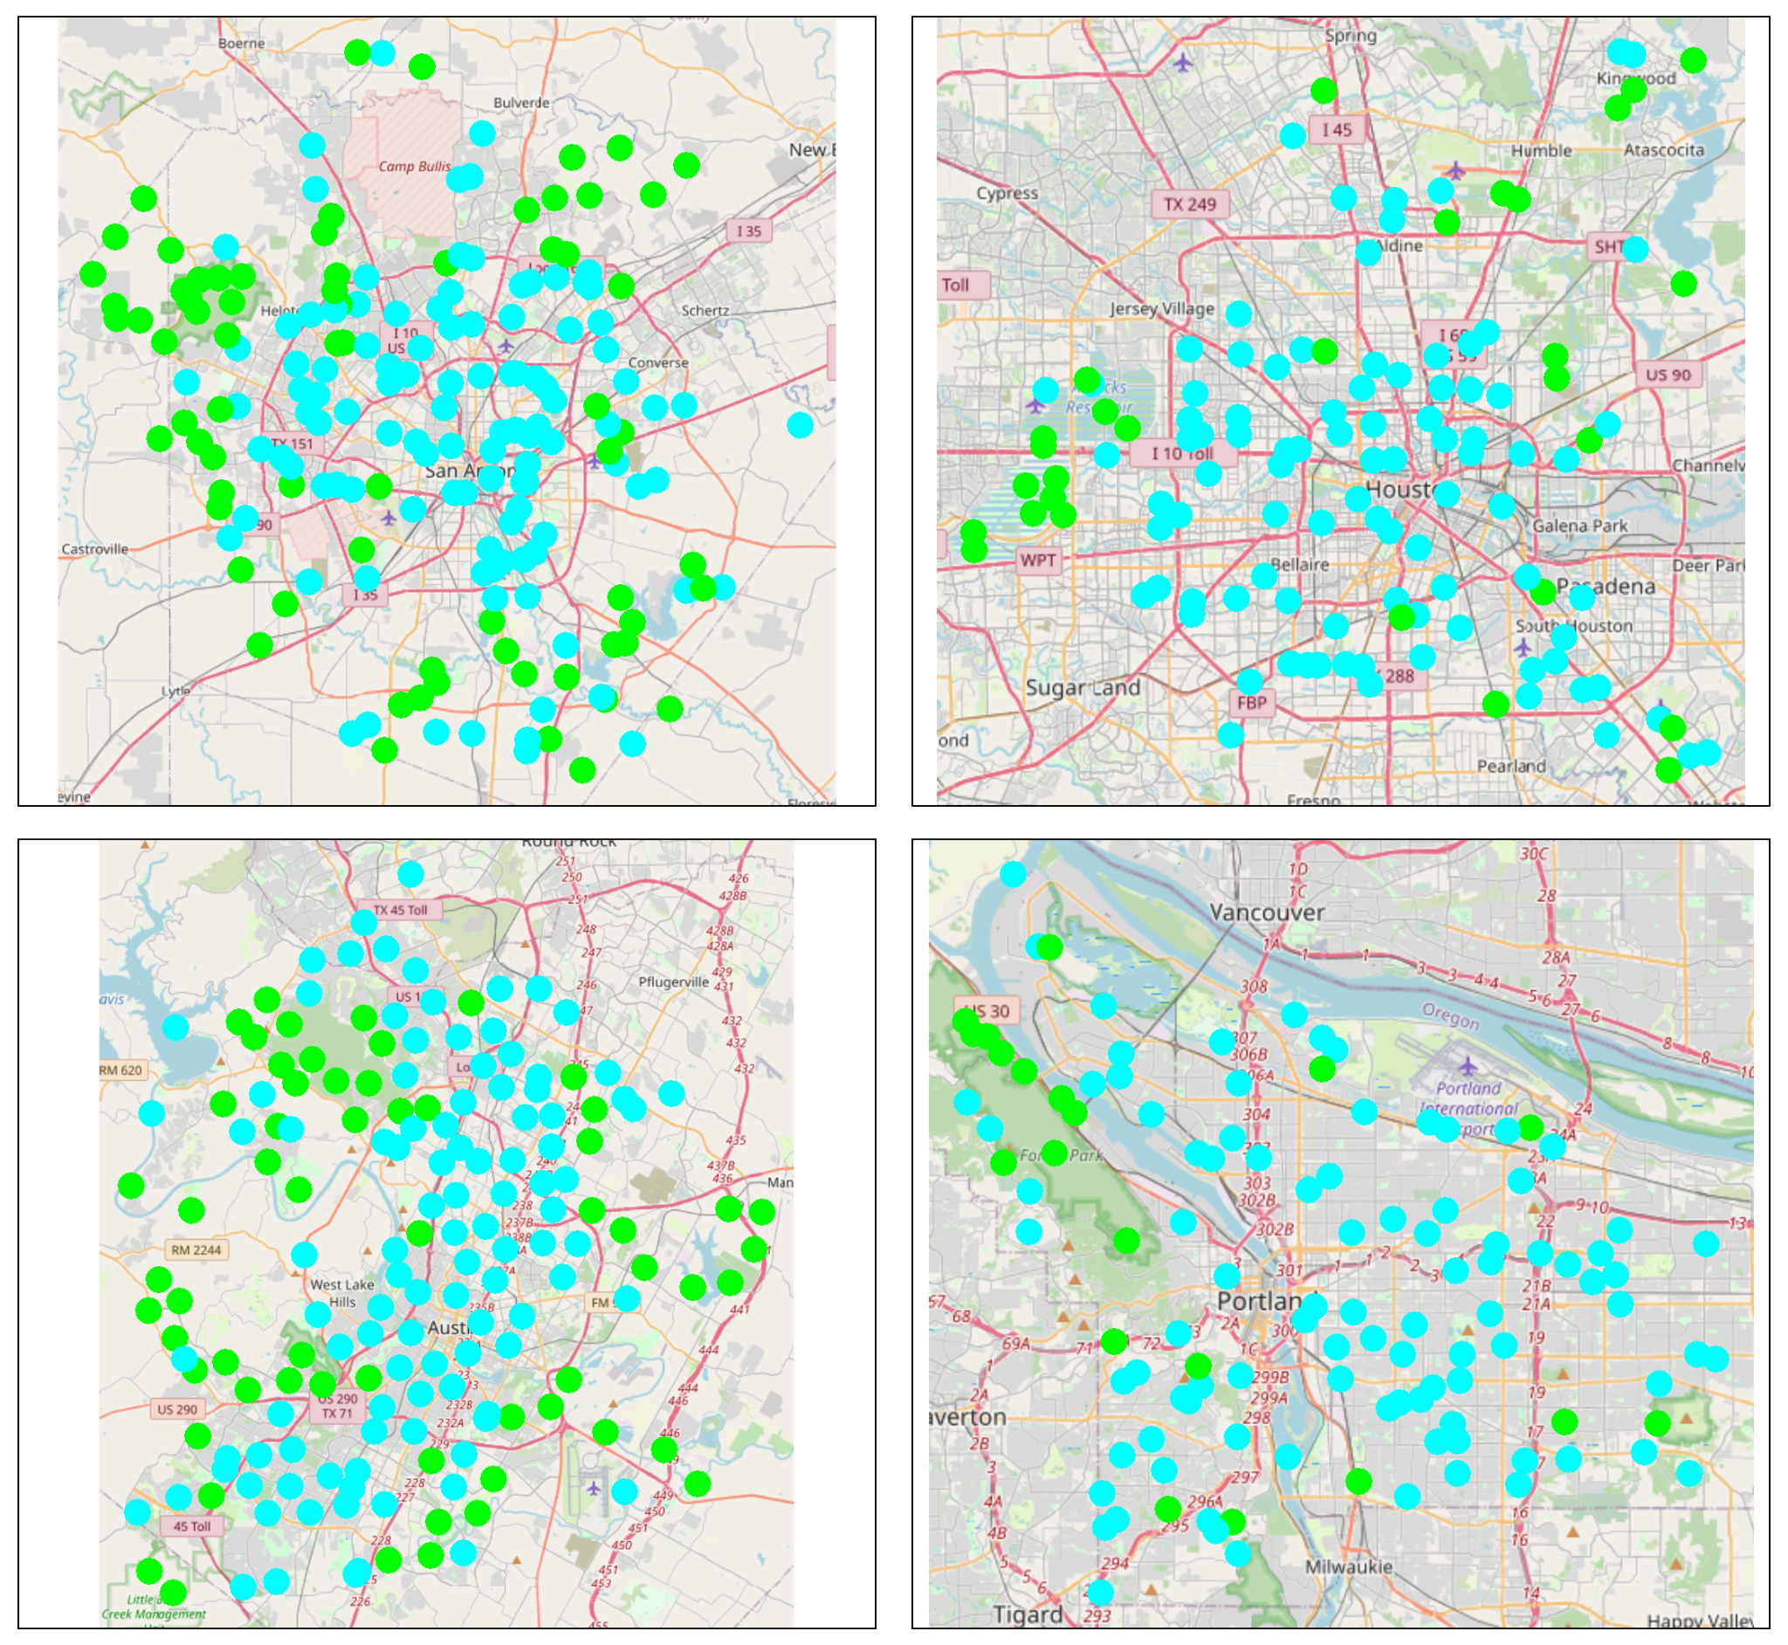

**Figure 1**. A map of the four cities, San Antonio, Texas (top left), Houston, Texas (top right), Austin, Texas (bottom left), and Portland, Oregon (bottom right). The blue points represent FIA sites we classified as ‘other’ and the green points represent FIA sites classified as forest.

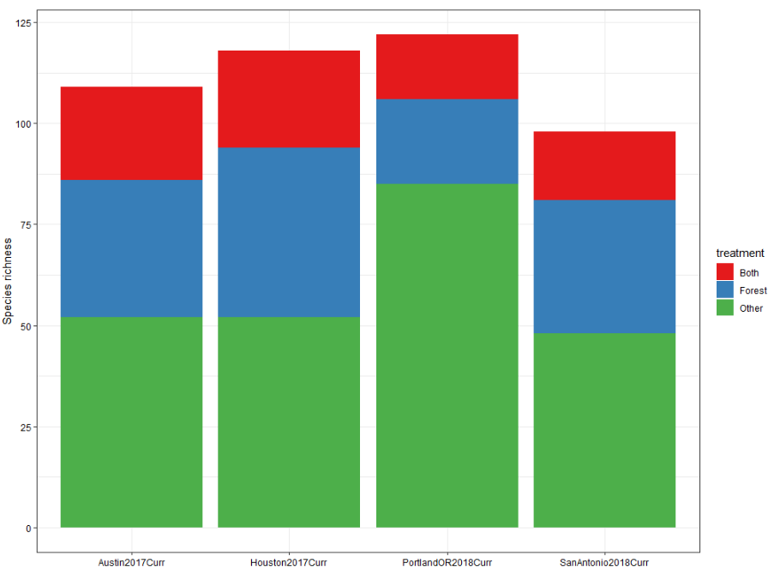

**Figure 2**. The total overall species sampled in forest, compared with other land use types, for the four cities in our analysis.

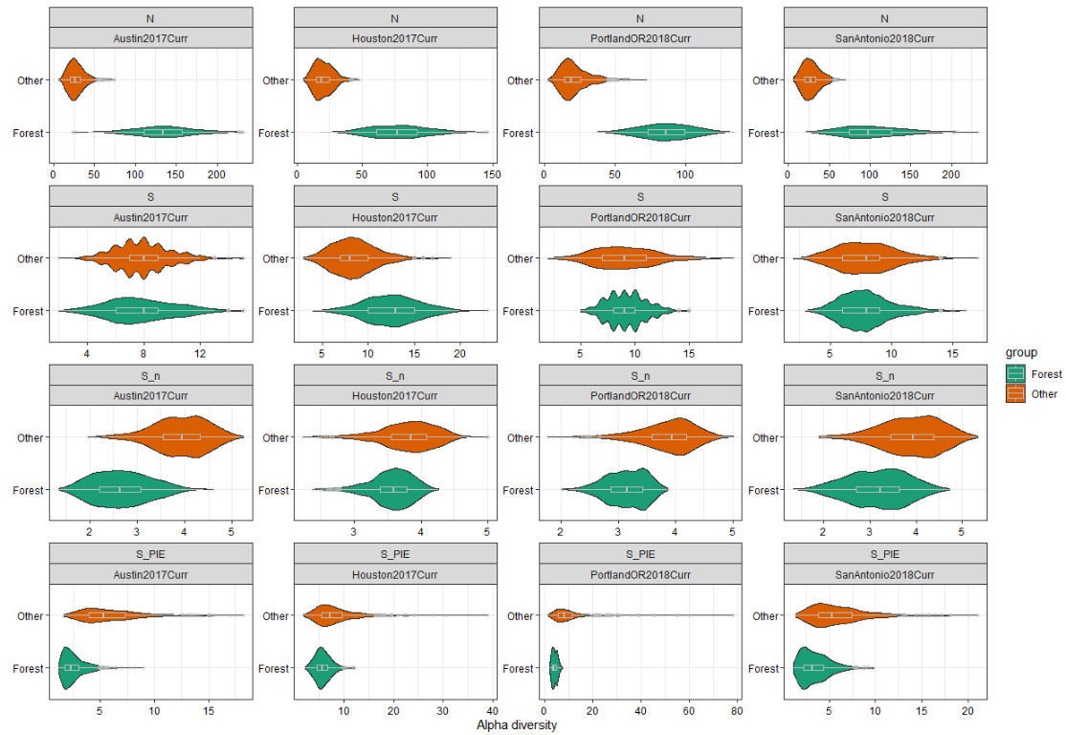

**Figure 3**. The results of our analysis for alpha diversity, showing the increase in abundance of trees compared with other land use types, the XXXXXXXX.

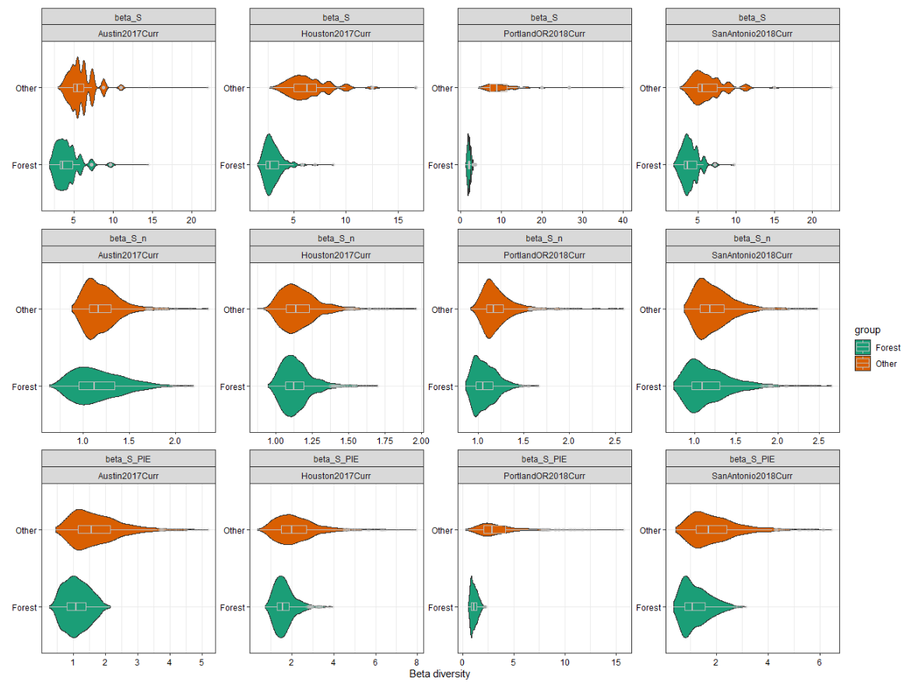

**Figure 4**. The results of our analysis for beta diversity, for species richness (top row), rarified species richness (middle row), and probability of interspecific encounter rate (bottom row).

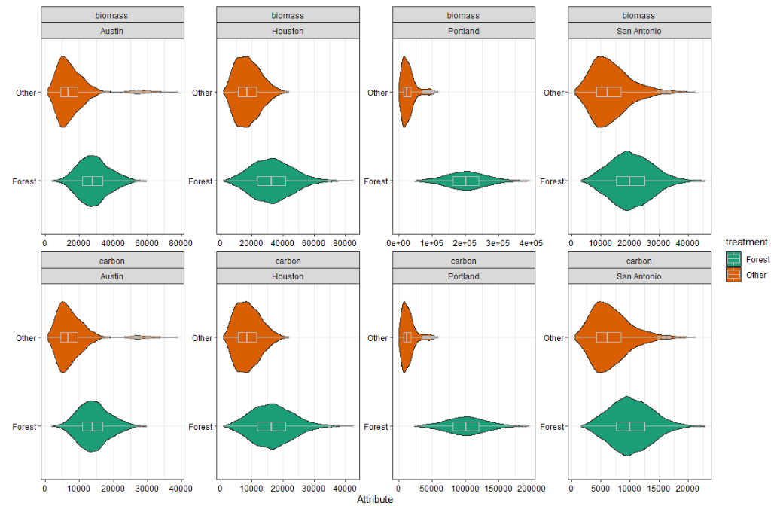

**Figure 5**. The resampled biomass (top row) and carbon (bottom row) for each city, showing that both biomass and carbon are greater in forests than other land uses.

**Tables**

**Table 1**. A summary of the number of sites, and total species richness, included from each of the four cities included in our analysis.

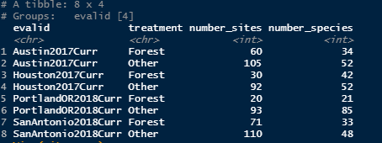

**Table 2**. Model results for three models, one for each diversity response variable.

